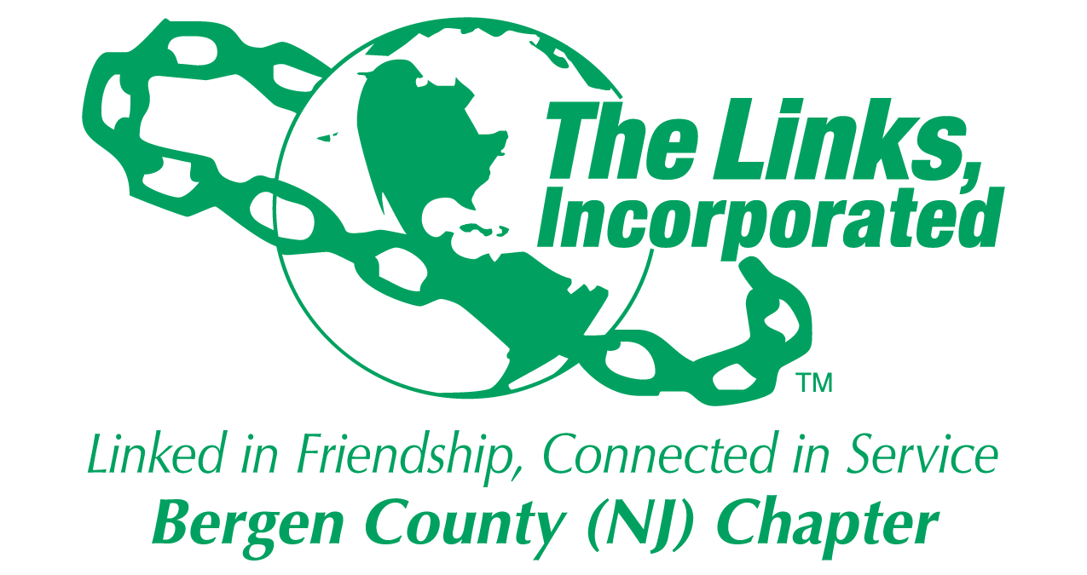
The Bergen County, New Jersey Chapter of the Links, Incorporated
Celebrates Area Scholars and Mother of the Year
at Tenth Annual
Mother’s Day Scholarship Award Luncheon
Scholarships to be Awarded to 14 Graduating High School Seniors
Teaneck Mayor Named Mother of the Year
For Immediate Release
Contact: Tamara Zachary
Phone: 973-528-8253

May 6 —The Bergen County, (NJ) Chapter of the Links Incorporated will award scholarships to 14 outstanding high school seniors at its Annual Mother’s Day Scholarship Award Luncheon to be held on Saturday, May 9th at The Venetian in Garfield, NJ. The Links will celebrate the 10th Anniversary of the luncheon event which benefits exemplary seniors who are continuing on to college or other educational opportunities after graduation. The organization also celebrates its Mother of Year. The honoree this year is Teaneck Mayor LIzette Parker, the township’s first African American female Mayor.
Christine Fowler-Phillips
President
Minnie Adams
Vice President
Beverly Baker
Treasurer
Shirley Myers Deering
Financial Secretary
Lesley Renee Adams
Recording Secretary
Kenetta Bailey
Corresponding Secretary
Bettye A. Easley
Program Coordinator
Nellie Jenkins
Linkspirational Leader
Jasmine D. Adkins
Parliamentarian
Jacquelyn Styles
Protocol Officer & Rituals
Chair
Theodora Lacey
Historian

Members
DeJuanna Adams
Diane T. Ashley
Althea Avery
Sharon Banks-Williams
Thelma Baxter
Patricia Chaney*
Hazel Cogar
Malaak Compton-Rock
Robin Cooper
Roslyn Daniels
Allison J. Davis
Linda Spradley Dunn
Tara R. Edmonds
Myrna Gillespie
Regine Guerrier-Love
Ann Guillory
Gloria F. Hall
Valerie Moore Hamer
Alicia Haughton
Margaret Haynes
Alicia T. Henderson
Nellie Jenkins
Verdia E. Johnson
Wilma Jones*
Tammy King
Ernestine Lowe
Ruth Lowe*
Marsha Mackey
Yolonda Baker Marshall
Jacqueline D. McLeod
Donna Mendes-LaMotte
Pamela T. Miller
Leslie Wims Morris
Myrna Morris*
Teresa A. Oakley
Beatrice Parrish*
Zandra Perry-Ogbomo
Frances Raines*
Gwendolyn Ramsey
Johanne Bryant Reid
Jill Stewart
Jewel Thompson*
Eva B. Vinson
Maredia Dionne Warren
Imogene Washington*
Ora Welch
Brenda Farrow White
Chee Chee Williams
Tamara Spinner Zachery
• * Alumni

The Bergen County (NJ) Chapter, Links Incorporated
PO Box 183
Teaneck, NJ 07666
www.bergenlinks.org
“This is our signature event,” said Bergen County Links President Christine Fowler-Phillips, “and one that we are proud to host each year to showcase the remarkable accomplishments of our youth and our Mother of the Year. We also have a lot of fun!” she noted.
The luncheon will be held on Saturday, May 9th from 11:30 am to 2:30 pm at The Venetian, 546 River Drive, Garfield, NJ.
Our Silent Auction, featuring one-of-a-kind items, is also online for bidding by the general public. We invite you to bid by going to our website at www.bergenlinks.org. You need not be present to win!
About the Links, Incorporated:
The Links, Incorporated celebrates more than 65 years as a women’s volunteer service organization committed to enriching, sustaining and ensuring the cultural and economic survival of African Americans and other persons of African ancestry. A premier international service organization with more than 12,000 members in 276 chapters located in 41 states, the District of Columbia, and the Commonwealth of the Bahamas, its members are influential decision makers and opinion leaders. The Bergen County (NJ) Chapter of the Links, Incorporated celebrated its 40th Anniversary in 2014.
###
List of Scholarship Awardees for 2015
Destiny McFadden — Hackensack High School
Breyana Hammond — Paramus Catholic High School
Edmon Berry — Bergen County Academies
David Victor — The Dwight Englewood School
Samuel Tatem — Paramus Catholic High School
Jillian Royal — Dwight Morrow Academies@Englewood
Kiara Cureton —Dwight Morrow Academies@Englewood
Ian Gray — Teaneck High School
Paula Scipio Menifee — Teaneck High School
Akua Boachie — Hackensack High School
Michael Amoako — Teaneck High School
Nikayla Barnaby — Hackensack High School
Justinna Dixon— Hackensack High School
Taylor Worrell-Stith — Teaneck High School

